WINCE setup and OS download

DOC. No.: | REV.: 00 |  |  | PRODUCT:
TITLE: WINCE setup and OS download |  |  |  | Project:
Prepared by: | Lewis Chen |  |  | Date: | 2010-1-13
Remark: | Approval:
Remark: |  | Department | Title |  |  | Signature
Remark: | 1 | Electronic R&D
Remark: | 2
Remark: | 3
Remark: | 4

Revision | Description of Change | Author | Date
00 | Start this article | Lewis Chen | 2010-1-13
01 | Update add LCD extension introduce | Lewis Chen | 2010-05-06

1. Overview 4
2. Environment setting 4
2.1. What you need 4
2.2. Disc space needed 4
2.3. Install 4
2.3.1. Install Visual Studio 2005 4
2.3.2. Install Visual Studio 2005 Service Pack 1 5
2.3.3. Install MSDN 5
2.3.4. Install Windows Embedded CE6.0 6
2.3.5. Install Windows Embedded CE6.0 Platform Builder Service Pack 1 6
2.3.6. Install WINCE6.0R2 7
2.3.7. WINCE6.0 Updates 7
2.4. S3C6410 BSP and SDK setup 7
2.4.1. Get source code 7
2.4.2. Install 8
2.4.3. Build your WINCE 8
2.5. Download WINCE to main-board 8
2.5.1. Main-board start up mode setting 8
2.5.2. Procedure 9
Appendix 14

Overview
This article is to introduce WINCE setup and OS download. And it assumes that you already have all the files which are necessary while installing the VS2005 and WINCE6.0.

Environment setting

What you need
- Visual Studio 2005
- Visual Studio 2005 Service Pack 1
- MSDN(optional)
- Windows Embedded CE6.0
- Windows Embedded CE6.0 Platform Builder Service Pack 1
- WINCE6.0R2
- Microsoft Device Emulator 2.0(optional)
- Virtual Machine Network Driver for Microsoft Device Emulator(optional)
- WINCE6.0 Updates

Disc space needed
Application | Space need
Visual Studio 2005 | 2G
Visual Studio 2005 Service Pack 1 | 1.8G(C: drive)
MSDN | 1.5G
Windows Embedded CE6.0(ARMV4I,X86) | 7.8G
WINCE6.0R2 | Less than 1G
Total:14G

Install
Copy all necessary programs to hard drive, this action will make installation faster. (Suggestion: Install all applications to system partition.)

Install Visual Studio 2005
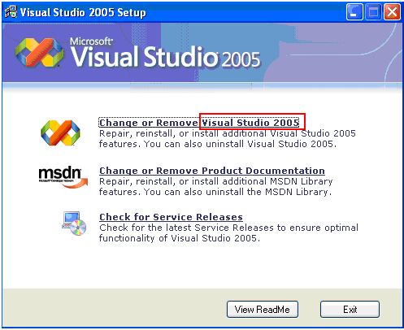
(Suggestion: Only install program language platforms which use to develop, and then the installation time could be shortened.)

Install Visual Studio 2005 Service Pack 1
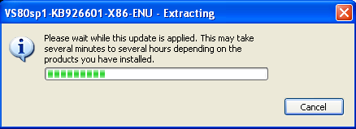

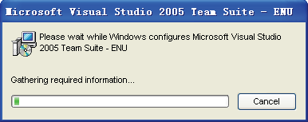

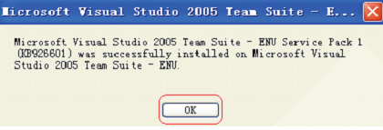

Install MSDN
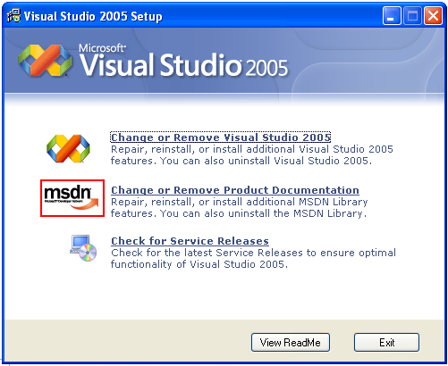

Install Windows Embedded CE6.0
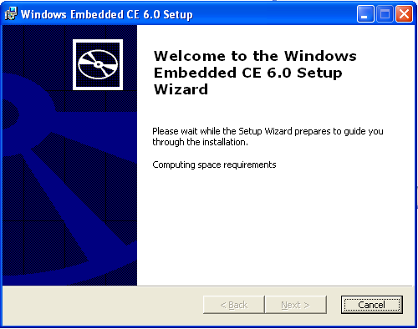
(Suggestion: Only install ARMV4I and X86 platforms which are used to develop, and then the installation time could be shortened.)

Install Windows Embedded CE6.0 Platform Builder Service Pack 1
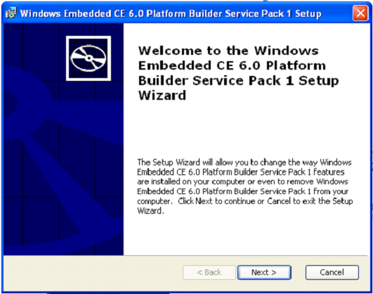

Install WINCE6.0R2
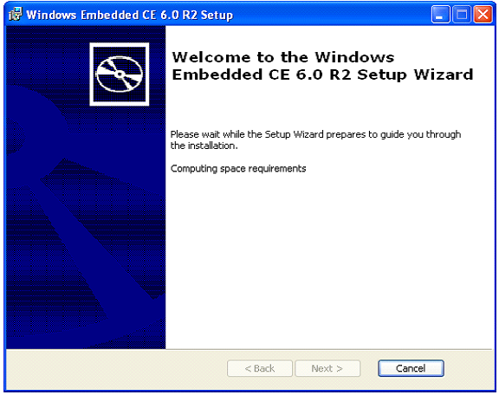

WINCE6.0 Updates
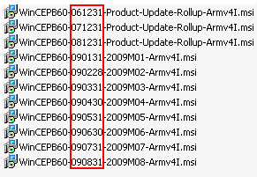
Do remind that the update pack should be installed one by one in time order.

S3C6410 BSP and SDK setup

Get source code
Checkout source codes from SVN
Location: http://10.10.0.45/source/trunk

Install
- Copy SMDK6410 directory to C:\WINCE600\PLATFORM,then remove the read-only attribute.
SMDK6410 location: http://10.10.0.45/source/trunk/BSP/S3C6410BSP/SMDK6410

- Copy S3C6410_SEC_V1 directory to C:\WINCE600\PLATFORM\COMMON\SRC\SOC,then remove the read-only attribute.
S3C6410_SEC_V1 location:
http://10.10.0.45/source/trunk/BSP/S3C6410BSP/S3C6410_SEC_V1

- Modify C:\WINCE600\PLATFORM\COMMON\SRC\SOC difs
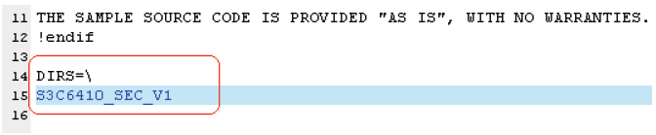

Build your WINCE
Build 75460 project.
Location: http://10.10.0.45/source/trunk/BSP/S3C6410BSP/75600
After the building finish, you will get three files at project output directory. (STEPLDR.bin, EBOOT.bin, NK.bin)
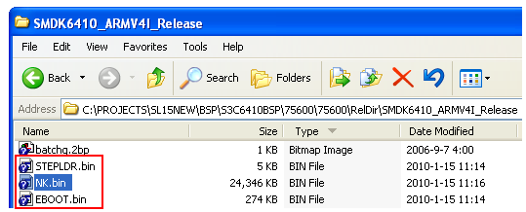

Download WINCE to main-board

Main-board start up mode setting
SWI pin | PIN1 | PIN2 | PIN2 | PIN4 | PIN5 | PIN6
SD-Mode | 1 | 1 | 1 | 1 | 0 | 0
Nand-Flash-Mode | 1 | 1 | 0 | 0 | 0 | 0
ON for 1, Off for 0
SD Mode is the only method to download at the first time.

PS: PIN5 and PIN6 mustn’t be turn on at the same time, or the main-board will be destroyed.
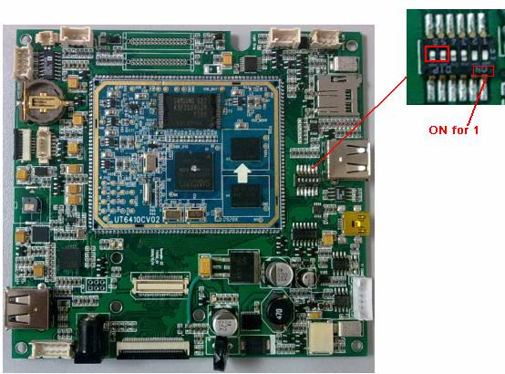

Procedure
- Step1 →Download startup code to SD card
  - Insert your SD card to PC
  - Then use IROM_Fusing_Tool.exe download IROM_SD_EBOOT.nb0 to SD card
  - Wait until it finishes
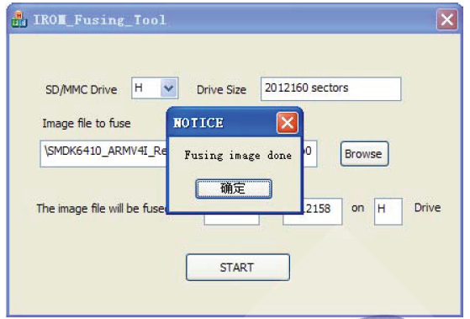

- Step2→Switch the switch to SD-Mode
Switch PIN1-PIN4 on, set main-board to SD-Mode
- Step3→Install USB driver of the main-board
Connect USB cable to main-board, then power up the main-board. The PC will ask for the USB driver, then the USB driver of main-board have to be installed.

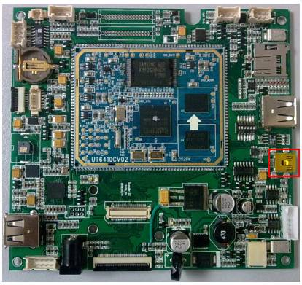

- Step4→Connect PC to the main-board via 232 interface
  - Connect PC to main-board via 232 cable to EBOOT and STEPLDR download interface.
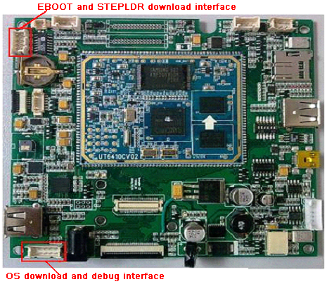

- Open DNW, then select the Baud rate and the COM port

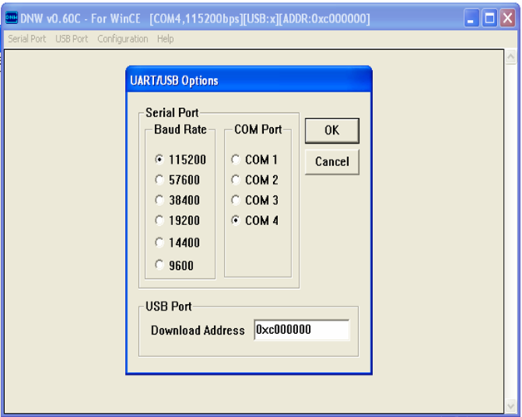

- Press connect button connect PC to main-board
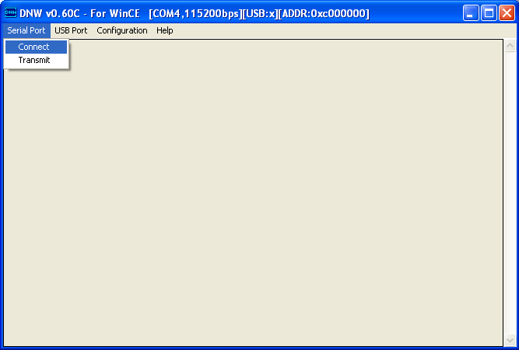

- Download STEPLDR.bin to NandFlash
  - Shoot circuit the reboot PIN to reboot the main-board.
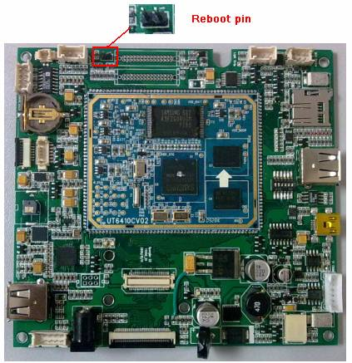

  - Press space bar while the main-board is rebooting. After entering the configure mode, then select the DOWNLOAD image now(USB)

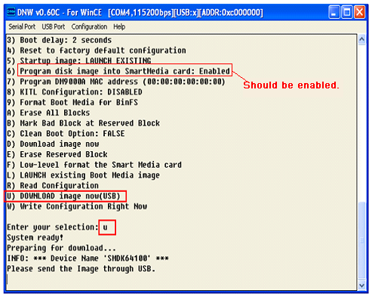
Configure mode

  - Select UBOOT to download the STEPLDR.bin to NandFlash
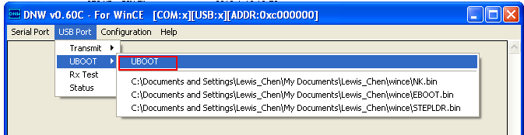

- Download the EBOOT.bin to NandFlash
  - Reboot the main-board
  - Enter configure mode
  - Select UBOOT to download the EBOOT.bin to NandFlash

- Download NK.bin to Nandflash
  - Shut down main-board
  - Switch main-board to Nand-Flash-Mode
  - Connect PC to main-board via OS download interface
  - Power up main-board
  - Enter configure mode
  - Select UBOOT to download the NK.bin to NandFlash
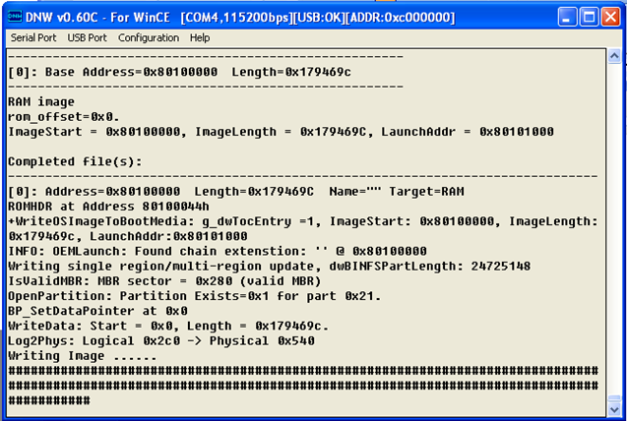

- Reboot main-board
Switch the main-board to the Nand-Flash-Mode, and then reboot main-board. Then the WINCE OS will run on the main-board.

Appendix
LCD extension:
In the new vision main-board, there are two switches, after changing these two switches setting, two different kinds of LCD displayer can be supported.
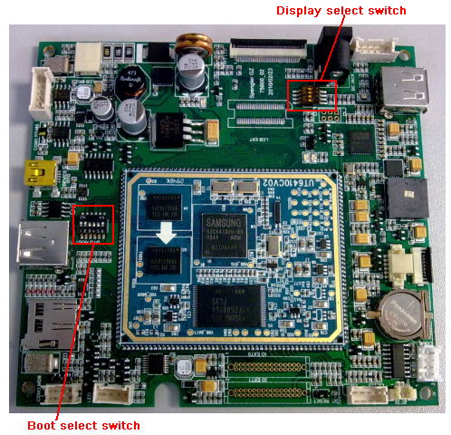
Display select switch setting:
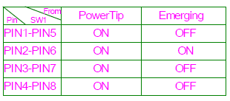
Boot select switch setting:
